**Circuit Diagram:**

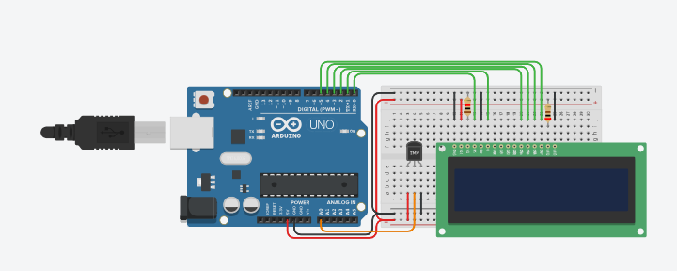

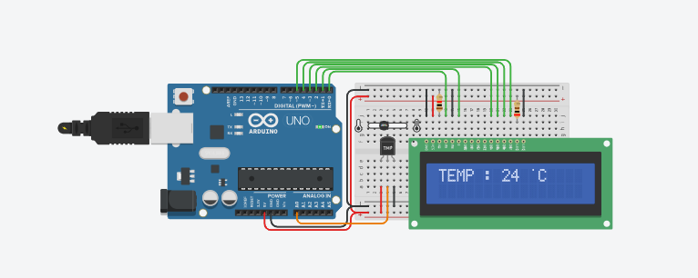

**Code:**

#include <stdio.h>

float readTemperature() {

return 24.0;

}

int main() {

float temperature = readTemperature();

printf("Current Temperature: %.2f°C\n", temperature);

if (temperature >= 25.0) {

printf("Warning: Temperature is too high!\n");

} else if (temperature <= 15.0) {

printf("Warning: Temperature is too low!\n");

} else {

printf("Temperature is within the normal range.\n");

}

return 0;

}

**Output Demonstration:**

